Project Apollo Oxygen concentrator - Prototype V2

Author(s): Adi Oltean

Contents

Project Apollo Oxygen concentrator - Prototype V2 1

Disclaimer 2

Overview 2

Principle 3

High-level design diagram 3

Components 4

Electrical system 5

Build instructions 5

Tools 6

Materials table (BOM) 6

Building steps – pneumatic system 10

1. Prepare the enclosure 10

2. Check that the four bottles are fitting correctly 12

3. Make one hole in the bottom of the bottle 13

4. Assemble the PTC fittings at each end of the four bottles 14

5. Add fittings to the bottle caps 18

6. Cut the supporting plate 19

7. Add holes to the supporting plate 21

8. Verify that the bottles fit correctly in the plate 21

9. Verify that the bottle + plate assembly fits into the inner bucket 24

10. Add a stop to keep the plate in place inside the inner bucket 26

11. Add the copper coil, the air filter and the PTC connectors. 29

12. Add the Quick Connect connector for the compressed air intake 31

13. (optional) Add two pressure gauges to the top of each zeolite tank 34

14. Add brackets around the copper tubing 35

15. Construct the lower pneumatic circuit 37

16. Assemble the top pneumatic circuit 41

17. Clear tank pressure testing 43

18. Load silica and zeolite tanks 44

19. Pressure test with tanks loaded 47

Building steps – electrical system 47

20. Cut out fan hole in the bucket lid 47

21. Add a mesh to protect fan blades from the exterior 49

22. Assemble the fan 51

23. Connect the Arduino with the ULN2003 board 52

24. Mark down the mounting holes for the Arduino board 54

25. Mount the Arduino and ULN2003 boards 56

26. Install connection block array 58

27. Pressurize and test the system with the Arduino driver 60

# Disclaimer

*Although we have strived hard toward O2 compatibility of the whole design, the V2 design in this document and related documents* ***does not*** *have any claims of O2 compatibility, medical safety or any other safety standards. All material/instructions are provided “as is” without any warranties implied.   
  
We encourage the reader to learn more about medical safety standards and* [*Oxygen compatibility*](https://en.wikipedia.org/wiki/Oxygen_compatibility)*, and about the risk of fire and other risks associated with oxygen concentrators in general.*

*Please note that in an oxygen-rich atmosphere many plastics are extremely sensitive to fire and we should assume that it may even spontaneously combust due to sparks caused by accidents or even electrostatic discharge!*

# Overview

The goal of Apollo V2 is to define a simple oxygen concentrator prototype that is easy to build with off-the-shelf materials available in local stores or internet (Amazon). The target cost is around $200, with possibility of having certain concentrators built under $100 if materials/components are sourced in bulk.

The main focus of V2 is an oxygen concentrator that can be built as fast as possible for urgent needs (COVID-19 scenarios?). Therefore, we prefer using widely available components and materials that can bought locally or over local internet shopping sites. We tried to not over-optimize for cost even though very inexpensive components such as fittings or electronics are available in bulk or for much less cost from overseas shopping locations such as Alibaba.

Also, in V2 we tried to define a simple, yet flexible design approach that anyone can start over and modify to its needs or according to the available components. We tried also not to overoptimize certain aspects of the design that may not be of value to some users. For example, the enclosure is kept very simple yet sturdy – we simply used two buckets that are very inexpensive at local hardware store. We felt that a more complex design would not have been useful as makers may choose to use a different enclosure design (based on plastic sheets for instances or even wood) if will be a better fit to their constraints at hand.

More details about the project overview and goals is located here: <https://github.com/oxycon/ProjectApollo/tree/master/Prototype%20oxygen%20concentrator/docs/v2>

## Principle

The main principle behind is called PSA[1] (pressure swing adsorption[2]). We use the properties of zeolites (materials having porous structures below one nanometer) to selectively adsorb certain gases. Zeolites have ceramic structures that have a extremely high ratio between internal surface and volume.

The reason this works is related with the fact that some gases have larger molecules. For instance, the oxygen (O2) molecule, at 0.152 nanometers, is much smaller than the N2 molecule (0.31 nanometers) or CO2 molecule (0.232 nm). Therefore, larger molecules such as N2 or CO2 have higher affinity of being retained (adsorbed) on the zeolite surface than O2 molecules.

The way PSA works is simple: we expose a tank containing beads of zeolites to air at moderate pressure (around 25 psi) for a few seconds. After the gas not adsorbed (O2 and Argon) is removed, the zeolite bed is then brought back to atmospheric pressure, and the cycle is repeated.

A double-bed version with two alternating tanks is more efficient than using a single bed. This double-bed process was discovered (and patented) about 50 years ago, and is known under the name of Skarstrom[3] cycle[4].

## High-level design diagram

All PSA oxygen concentrators follow the same components, depicted in the following diagram[5]:

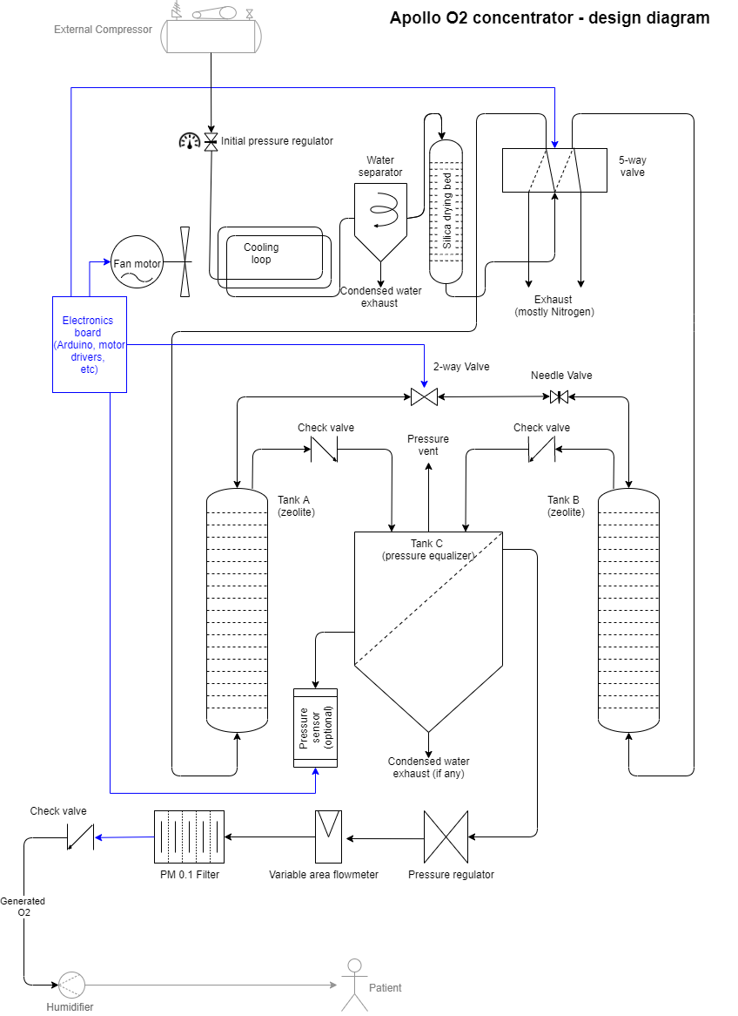

## Components

In the diagram above we have the following components:

1. An external source of compressed air (for instance a compressor). A medium-size home compressor is preferable - about 4 cfm and 40 psi minimum.
2. A water separation system since the compressed air can contain some amount of water which should not get into the zeolite beds (otherwise their efficiency will be greatly reduiced. The water separation consists of a cooling loop made out of ¼ copper tubing and an inexpensive water filter from Harbor Freight Tools. The same filter also filters out oil or other impurities coming from the external compressor.
3. A silica bed for drying the compressed air, in case some water vapors are still left over after the water separation stage. This silica bed is made out of a 2L soda can bottle.
4. A 5-way valve that alternately routes the compressed air to one of the two zeolite beds. The same valve also discharges the other zeolite bed to the atmospheric pressure.
5. Two zeolite beds, each made out of 2L soda bottles
6. A 2-way valve (cross-flush) that briefly connects the outputs of the zeolite beds. We have also added a needle valve next to it to allow the builder to fine-tune the cross-flush process.
7. Two check valves that allow the output of the O2 zeolite tank to accumulate in a storage tank (also a 2L soda bottle).
8. A pressure regulator and flowmeter combo which regulates the speed of produced oxygen
9. A final filter to ensure that the air sent to the patient is clean of particulates.
10. A check valve on the O2 line to prevent any gas or contamination to flow back into the concentrator when turned off.
11. The device can also have an optional humidifier to add some moisture to the generated oxygen. This humidifier is out of scope of this design document.

## Electrical system

An O2 concentrator also has an electrical system that actuates the 5-way and 2-way valves according to the O2 output pressure (detected through a sensor). The same electrical system can also offer audible and visual alarms if the system ceases to work as expected (O2 concentration low, valve failure, low pressure, etc). In order to assist the detection extra sensors may be added such as an O2 sensor, a flow sensor, etc. The electrical system may also have a rechargeable battery to alert the staff or the patient if the electrical power is removed from the circuit.

In our prototype V2 we use a simple Arduino board to implement valve timing. We have not implemented advanced alarms/diagnostics.

# Build instructions

The following paragraph details the build instructions for the Apollo V2. We have favored the metric system assuming that the device needs to be built in a large variety of countries. Imperial/SAE dimensions are also provided whenever needed[6].

## Tools

In the building process we have avoid advanced tools such as 3D printers, laser cutters, water-jet cutters, welding equipment, etc.

* Portable drilling machine + M3, ¼” drill bits, etc.
* A set of Forstner drilling heads to make holes of about 1¼“, ¼” etc. You can also use plastic drill bits.
* Saw for cutting various materials such as upper supporting plastic plate
* Scissors/knives to cut tubing to the correct dimensions
* Ruler or caliper
* Low-pressure gauges (optional, for diagnostics). These do not need to go higher than 30 psi.
* Long (1.5 ft) ratcheting tool to allow the muffler to be screwed in from the inside of the 2L plastic bottle. The tool needs to be of the thin type (that will fit through the bottle opening – see drawings below)
* Deburring tool for PET bottles that may fit the ratcheting extension above.
* Screwdriver, plies

## Materials table (BOM)

In this design we have preferred off-the-shelf components typically available in hardware stores or on the fast internet shopping websites such as Amazon Prime or eBay. Parts and materials were chosen based on availability in stores/ inventories in the local countries such as United States.

A detailed BOM (Bill of materials) for United States is located in a separate file[7].

Main components:

* **Enclosure/structure:**
  + Two regular 5-gallon buckets and a bucket lid from Home Depot or Harbor Freight Tools. These structures offer enough rigidity to the whole apparatus, which is important given that the silica and zeolite beds are heavy and the total mass can add up to a few kg. Also, please note that the device will be probably flipped up a few times during build/maintenance and needs to preserve integrity[8].
  + A firm 1ft x 1 ft transparent plastic plate (1/4” thickness recommended) is also recommended to hold the four bottles in place[9].
* **Gas tanks**
  + We recommend using four 2L soda bottles. PET material in regular soda bottles offers several advantages:
    - Very inexpensive and available everywhere
    - Pretty good resistance at much higher pressures (burst pressure is higher than 250 psi).
    - They are easy to leak-proof. The cap can be easily opened and closed without introducing leaks.
    - PET material is also fairly resistant to cyclic stresses.
    - O2 compatibility is acceptable. The PET/PETG material doesn’t burn easily compared with the vast majority of plastics.
    - They are transparent, allowing the user to inspect the inside of a tank. For instance, it is easy to see when a silica bed is saturated with water due to its color change.
* **Fittings and O-rings** 
  + The fittings around the 2L gas tanks are very important. At each end of the 2L gas tank you need one fitting (except at the bottom of the O2 storage tank) so you need seven such fittings.
  + Multiple variants are possible, such as the combination of the following parts:
    - A 1/8 NPT bronze muffler situated inside the tank
    - An O-ring Viton gasket
    - An PTC Straight Bulkhead Female Fitting 1/4" OD, 1/8" NPT
  + Other variants are possible (detailed in the building document)
  + Care needs to be taken when designing the sealing of a fitting system. It needs to easily hold pressure for a long time and should be easy to take apart and maintain.
  + The O-rings need to be O2-compatible. They should not harden over time in pure oxygen atmosphere nor be a fire hazard. Materials such as Viton are recommended.
* **Tubing/piping work**
  + We have used Push-to-connect (PTC) fittings and tubing in the whole design. These are easy to put together and reopen as necessary. Note: PTC fittings from regular sources such as Amazon may not be O2 compatible.
  + We recommend using ¼ or 6 mm tubing and sticking with that standard. Important: you may not want to use ¼ tubing with 6 mm PTC adapters or viceversa, even though they look similar.
  + Some sellers on Amazon sell fitting kits including many straight/angle PTC fittings, check valves, ¼ NPT PTC adapters, 1/8” NPT PTC adapters, etc.
  + The cooling loop can be made out of ¼ copper or aluminum tubing. We recommend the 10’ copper tubing from Home Depot which comes pre-coiled at 1’ diameter which fits nicely inside the top of the bucket.
  + You also need proper fitting to hook up the compressed air line. A male or female ¼ Quick-connect coupler will work.
* **Zeolite**
  + Not all types of zeolites are a good match for oxygen adsorption. We recommend 5A[10] or 13X zeolites. These should be available over eBay or other online seller sources. Price for a kg of zeolite starts at around $6/kg. 13X seems to be a more resilient type of zeolite that works across a larger variety of conditions.
  + Zeolite can be also recycled/reconditioned from used concentrators through documented processes such as heating it in an oven with some control of exposure time/temperature[11]. Please assume that used zeolite may have been biologically contaminated if the used O2 concentrator comes from a medical facility, so care needs to be taken in reconditioning it in a safe manner
* **Silica beads**
  + There are inexpensive sources of silica beads over the internet. Silica beads can be easily dried by heating them for a few hours in an oven.
* **Pneumatic components**
  + 2-way valves and 5-way valves (of Chinese origin) are easily accessible on Amazon or EBay for around $10/valve. Please note that their seals may not be O2 compatible so the 2-way valve may need the valve replaced with an O2-compatible variant.
  + A water/oil filter and separator is recommended after the cooling tubing. We recommend the water separator that has a variable opening at the bottom which can be slightly kept open to ensure constant draining of the accumulated water (as opposed to periodic manual purges)
  + An oxygen flowmeter with an attached needle valve is critical to guarantee that we output O2 at the correct flow rate
  + A compressed air regulator is important since we want the compressed air to not exceed a certain pressure such as 25-30 psi.
  + For high O2 concentrations (higher than 45%), an extra needle valve is needed to fine-tune the orifice opening between the outputs of the two tanks.
  + (optional, but very useful) two pressure gauges can be used for pressure testing.
* **Electrical system and electronics** 
  + The system uses a regular 12V PC fan to cool down the water-cooling loop. Note: a fan may not be necessary if the compressed air hose connecting the concentrator to the compressor is extremely long such as 25-50 ft.
  + The timing is controlled via an inexpensive Arduino board. The valves can be driven using Darlington arrays, MOSFETs, SSRs, etc. such as the inexpensive ULN2003 board. Valve current is typically very small (0.5A)
  + If a failure protection system is set up (assuming pressure, flow and O2 sensors are present or systems that test valve functionality), the system may also have a buzzer and LEDs showing a diagnostic code[12].
  + Power supply. A 12V 1.5A power supply is recommended.
  + A few connection wires (Arduino 0.1” header wires)
  + A Push-style connection block array
* **Miscellaneous items**
  + Teflon tape is recommended for all sealing work.
  + In this category we have put other items that do not have a clear category
  + An M3 screw set (or equivalent) is recommended to affix the 12V fan to the bucket lid
  + Similar “drive in” screws or zip ties are needed to attach the valves to the enclosure
  + Optionally, the upper plastic plate can be kept in place inside the bucket using some wood or plastic holders which can be improvised from metal sheets.
  + A piece of metallic or plastic mesh to protect the fan input intake from the environment. Needs to cover the top of the 12V PC fan

## Building steps – pneumatic system

We estimate that building the device should take a few hours provided that all the materials have arrived and the tools are available.

* Assembly photos are available on Github: <https://github.com/oxycon/ProjectApollo/tree/master/Prototype%20oxygen%20concentrator/Photos>
* Drawings are located here: <https://github.com/oxycon/ProjectApollo/tree/master/Prototype%20oxygen%20concentrator/Drawings>

### Prepare the enclosure

Take one bucket, drill four equally-distanced holes at the bottom. The distance between the hole center and the center of the bucket needs to be 8 centimeters.

This will be the inner (top) bucket that will hold the four tanks.

The outer (bottom) bucket does not need any holes, and will hold the inner bucket at a certain distance from the ground. The gap left between the two buckets must be wide enough to contain the pneumatic circuit at the bottom of the apparatus (about 1 ½” .. 2”gap).

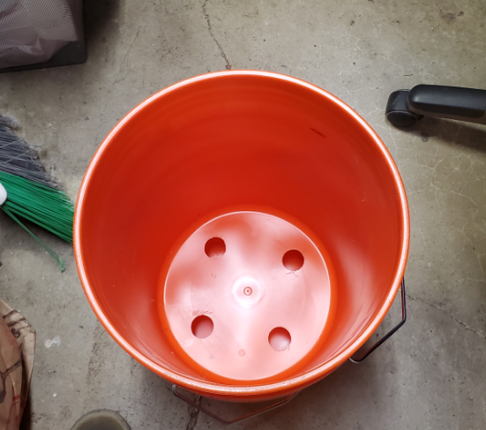

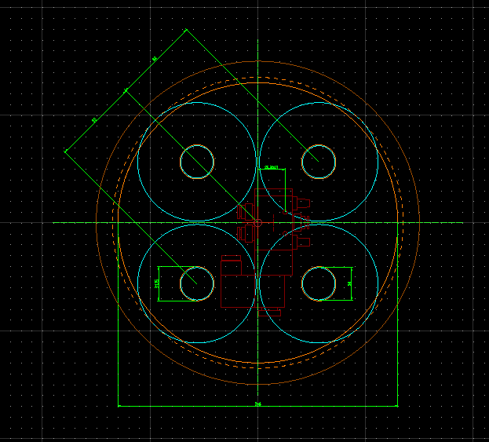

(from <https://github.com/oxycon/ProjectApollo/blob/master/Prototype%20oxygen%20concentrator/Drawings/v2/bottom%20bucket.dwg> )

### Check that the four bottles are fitting correctly

Ensure that the caps of each of the four bottles are penetrating the holes just made. If the bottles are too large for your bucket you need to find a bucket with a larger diameter or thinner bottles.

It is essential the four bottles will rest on the bottom of the bucket with the caps sticking out.

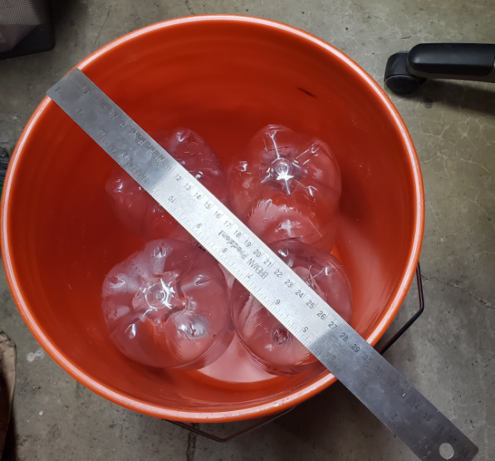

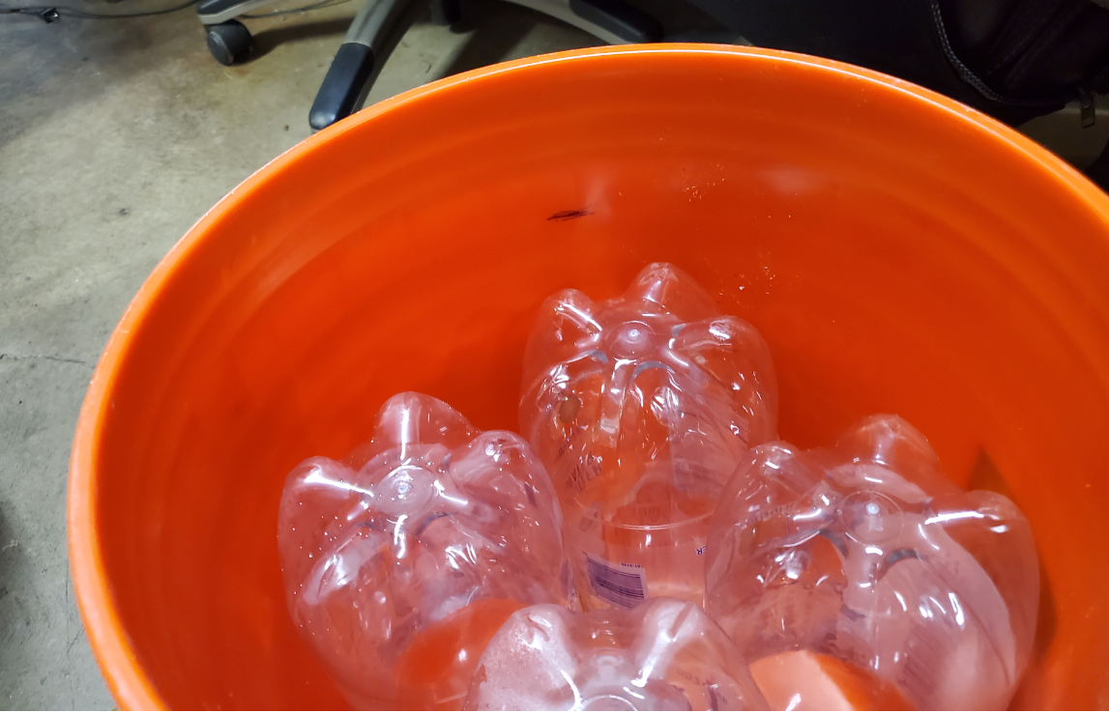

### Make one hole in the bottom of the bottle

With the 1/8 NPT muffler used below (see drawings below) we need a ¼ hole at the bottom of each bottle.

First, you need to carefully drill the soda bottle at the bottom using an exact hole that would allow the fitting to go through.

Pay special attention at deburring the hole (also do not deburr too much as it can cause leaks!)

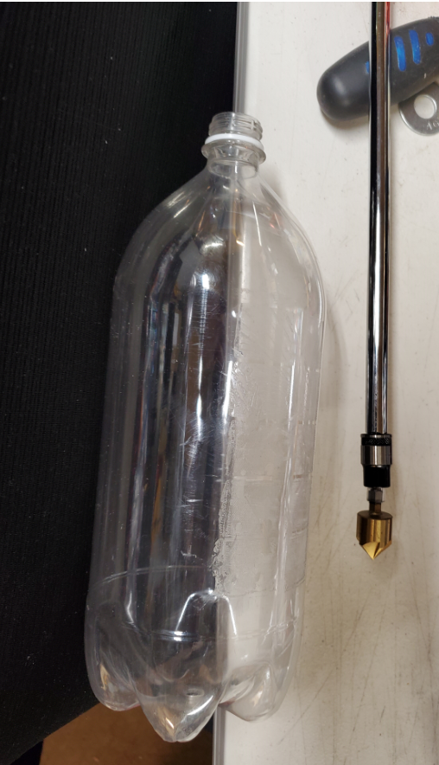

### Assemble the PTC fittings at each end of the four bottles

Remember that the fourth bottle is just an O2 storage tank so it only needs fittings on the top, so you may need only 7 fittings total.

This is one fitting variant using

* A 1/8 NPT bronze muffler situated inside the tank
* An O-ring Viton gasket
* An PTC Straight Bulkhead Female Fitting 1/4" OD, 1/8" NPT

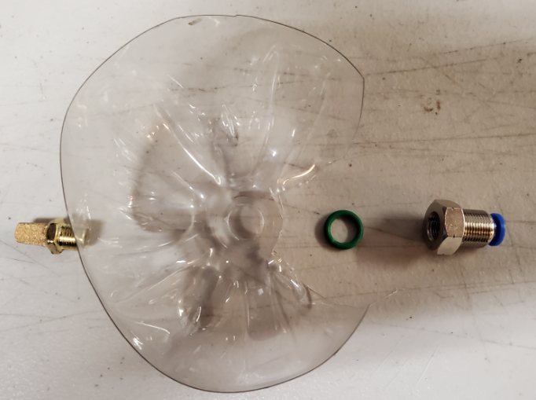

Here is how the fitting looks like assembled. Please pay special attention to the position of the O-ring seal which needs to sit on the outside (not inside), resting on the valve, blocking the air to come out.

Also, the muffler needs to be located inside the bottle to not allow the zeolite/silica beads to come out in the tubing area.

You might need to use a washer to hold the muffler inside the bottle. The O-ring needs to be tight on the fillet (not loose). The fitting does not need to be extremely tight, otherwise the O-ring may get damaged.

You need to use a ratcheting tool to ensure that the 1/8 NPT muffler is tightened from the inside of the bottle.

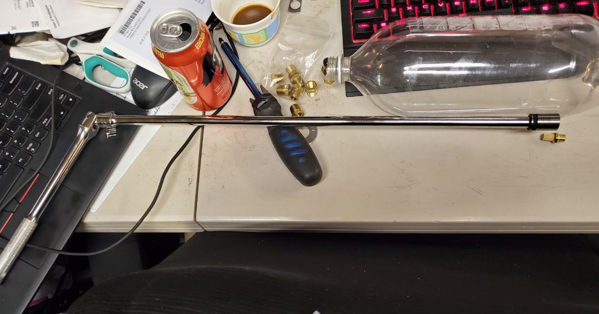  
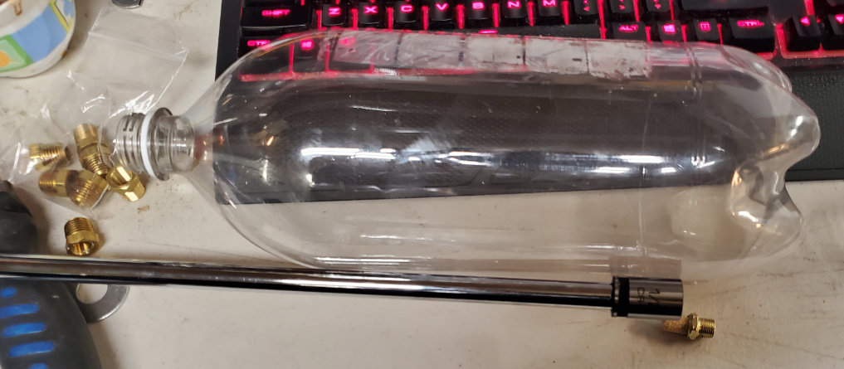

Here is a picture with the system assembled:

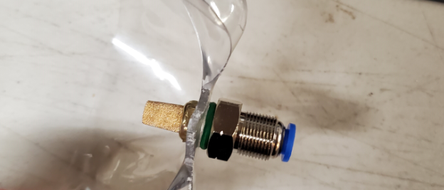

Pay attention and make a note of of the diameter of the fitting “sticking out”. This fitting needs to be supported by the top support plate (to be discussed next section).

Here is another possible fitting variant:

* 1/8 NPT muffler
* 1/8 NPT to ¼ NPT adapter (also serving as a sealing wall)
* ¼ NPT female PTC connector.

Note that you need Teflon tape to seal the connection between the ¼ NPT male and female.

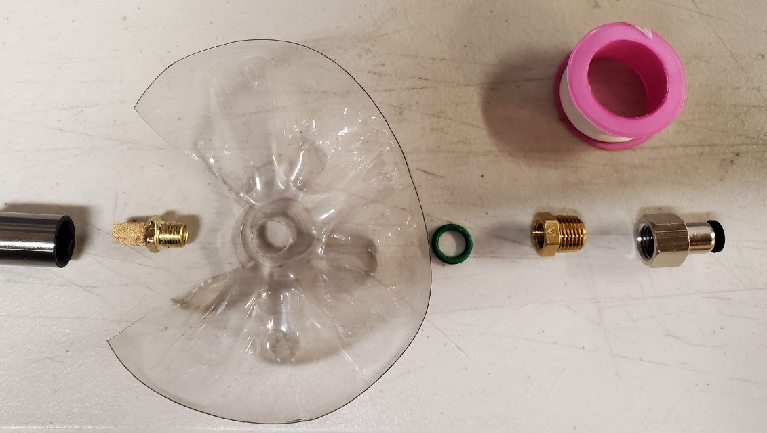

And here is the connector assembled:

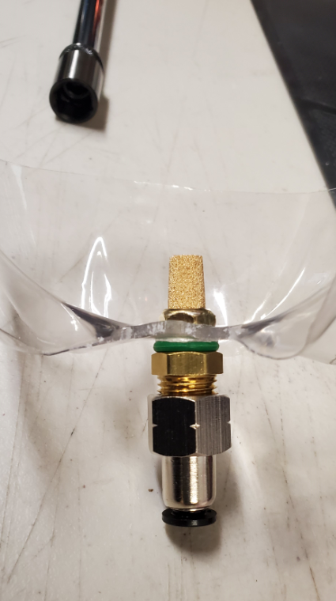

### Add fittings to the bottle caps

You need to do a similar fitting installation process for your bottle caps.

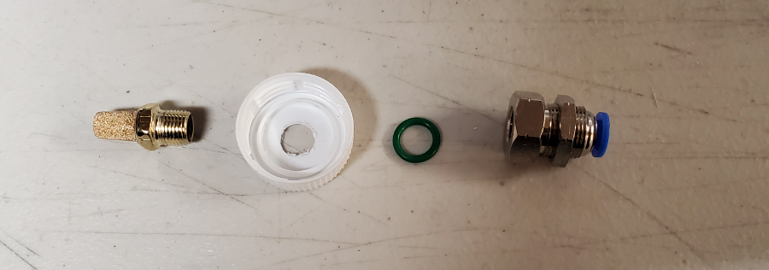

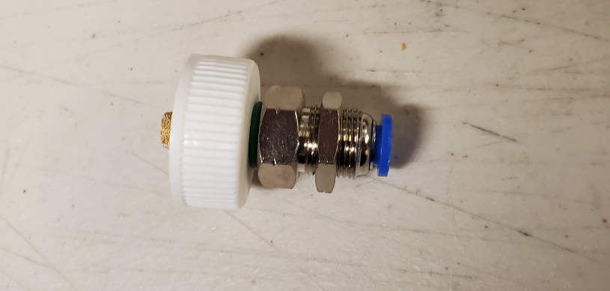

### Cut the supporting plate

The four bottles need to be kept inside the inner bucket using a top plate (disc).

This disk, in turn, needs to fit in the bucket horizontally, resting on top of the bottles.

The diameter of the disk depends on the diameter of your bucket at the height of where the four bottles are situated. In my case I have measured 14 cm radius but your dimensions may be different. If you undercut the disk it is not a big deal.

The disc can be cut from any plastic. Transparent plastic is recommended so we can visually inspect the four holes from the top.

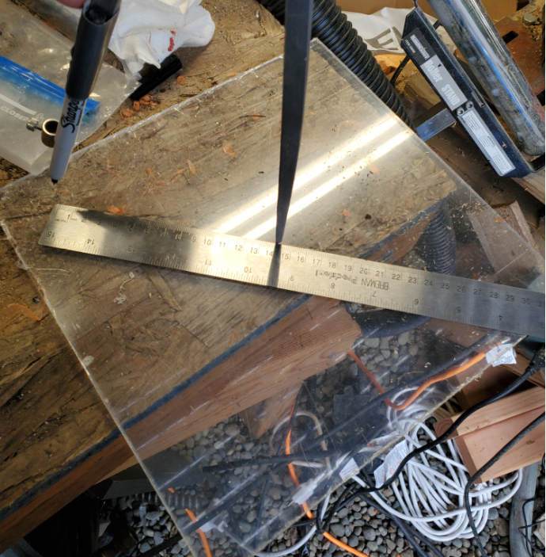

After marking the cutting circle you can use a regular saw to cut the acrylic.

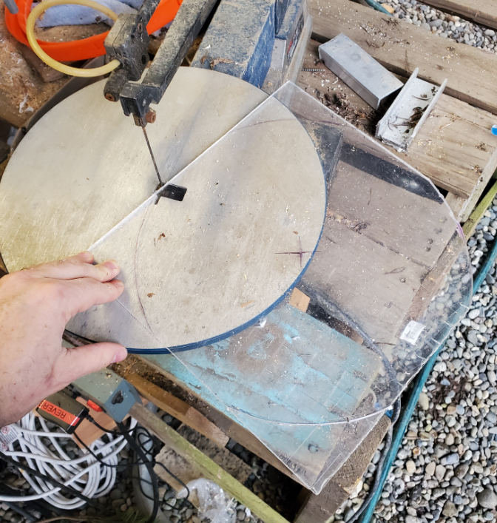

You also need to drive four holes in the plate (the center of each hole positioned at 8 cm distance from the center of the round disk). The diameter of these holes needs to slightly exceed the diameter of your top fittings.

### Add holes to the supporting plate

You need to add the following holes:

* Four holes for the bottle fittings
* One hole for the air filter, which will be supported on the top plate.
* One or more holes for connecting the electric circuit to the 5-way valve at the bottom of the bucket. Remember to add similar such holes for the electrical wires at the bottom of the inner bucket!

### Verify that the bottles fit correctly in the plate

At the end of this exercise you can now mount the four bottles on the top plate.

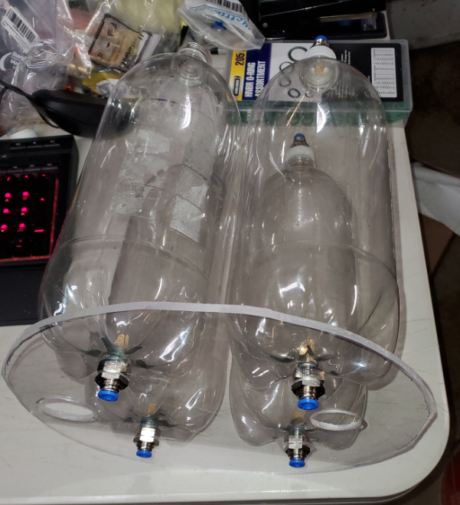

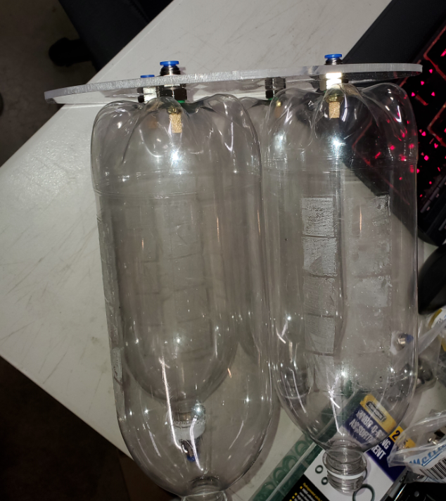

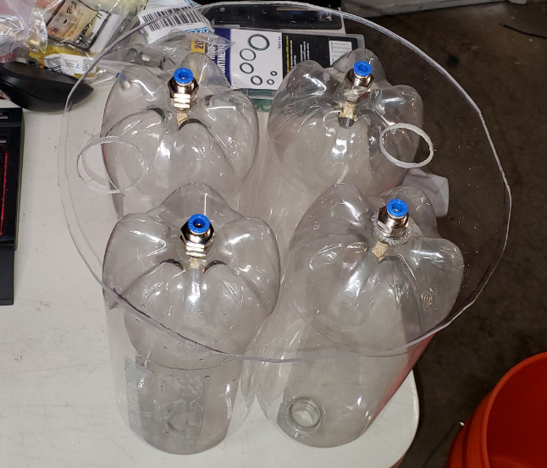

### Verify that the bottle + plate assembly fits into the inner bucket

After assembling the plate, verify that the plate fits inside the bucket, and that the four bottles have their caps sticking out.

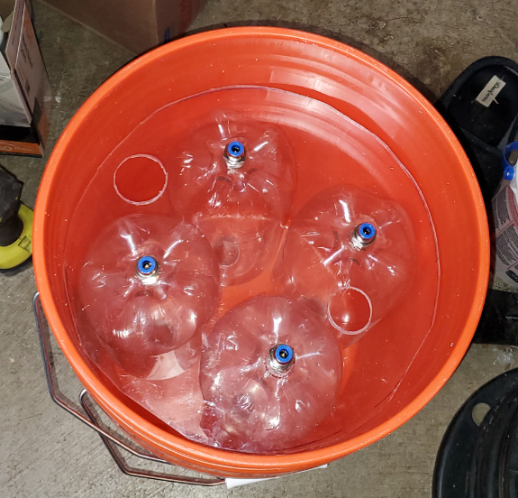

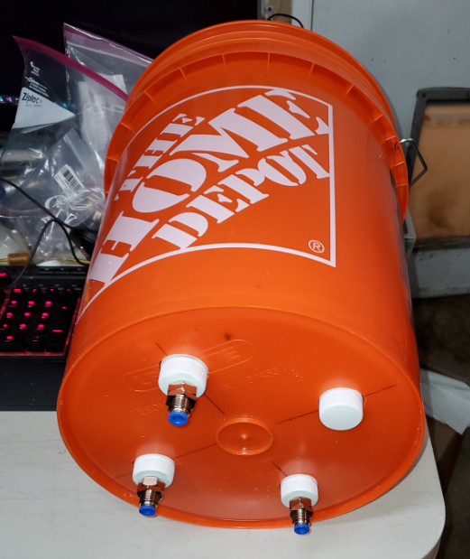

### Add a stop to keep the plate in place inside the inner bucket

*Attention: Make sure you drill all the necessary holes in the bottom of the inner bucket. Drilling holes when bottles are already fixed in place can damage them!*

We used a piece of wood. Anything similar could be used.

Important: the bottles can get quite heavy and you will flip the bucket quite often during testing/zeolite loading/silica loading/unloading so pay attention to the solidity of the stop!

The stop can be simply screwed in into the bucket plastic.

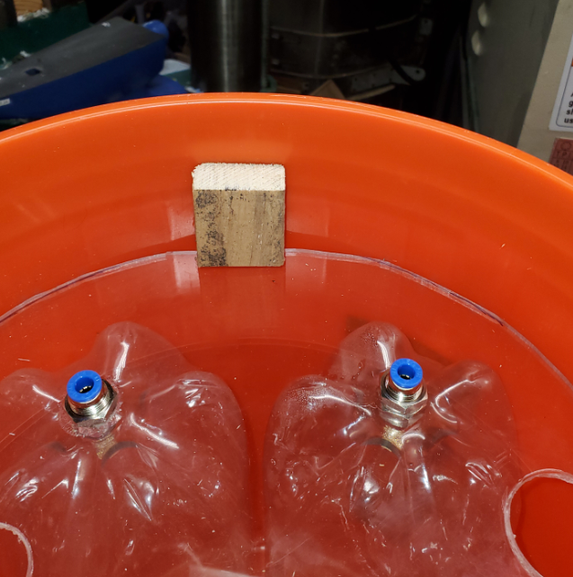

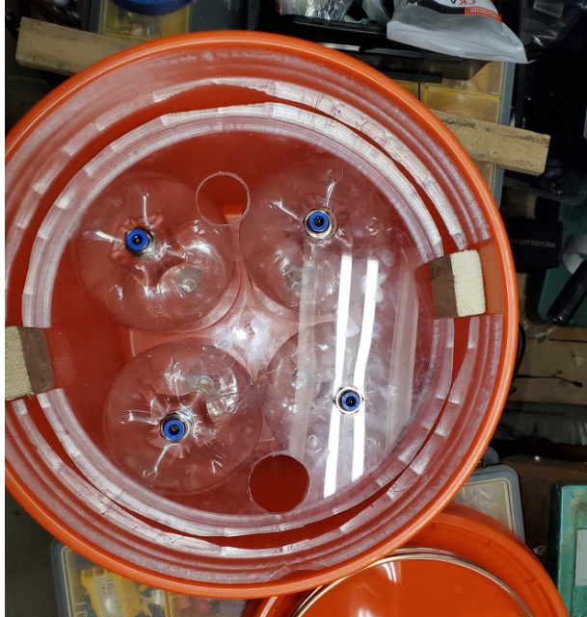

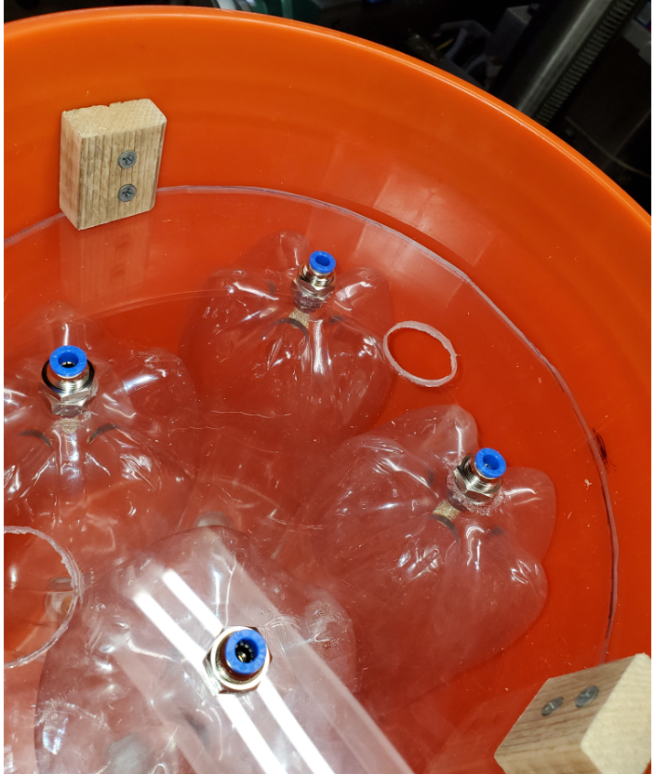

### Add the copper coil, the air filter and the PTC connectors.

I do not recommend coupling the copper coil to the filter directly – a small plastic line is recommended to allow better pressure fit and more flexibility of the whole system.

Pay attention to the arrow indicating the air direction in the filter.

Note that we connected the output of the silica bead bottle via a corner PTC connector. This one is connected to the bottle via a 1” plastic tube.

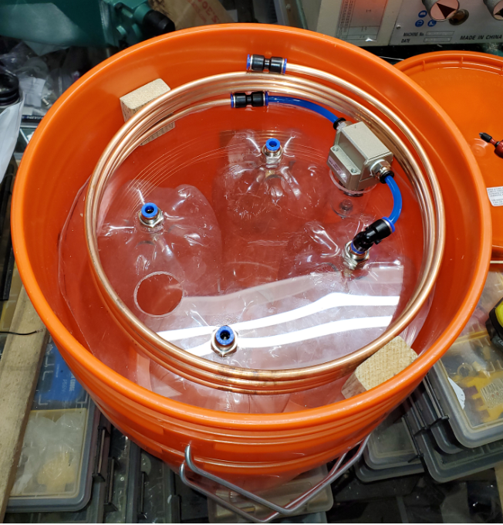

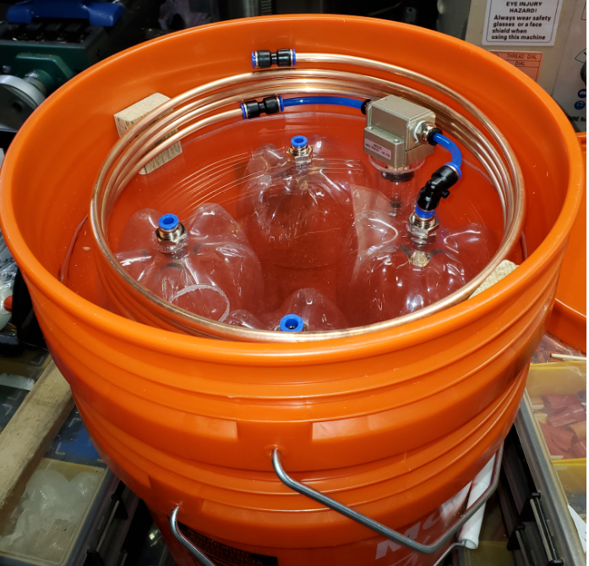

### Add the Quick Connect connector for the compressed air intake

Here I have simply used an inexpensive ¼” NPT QuickConnect, connected to the ¼” line via a PTC fitting.

You may want to also add a washer to the ¼” NPT/PTC fitting.

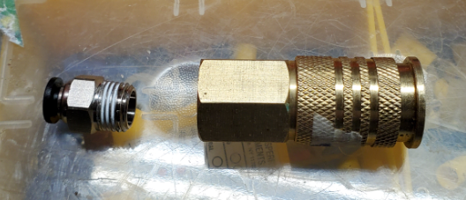

A hole needs to be made in the bucket to fit this assembly securely.

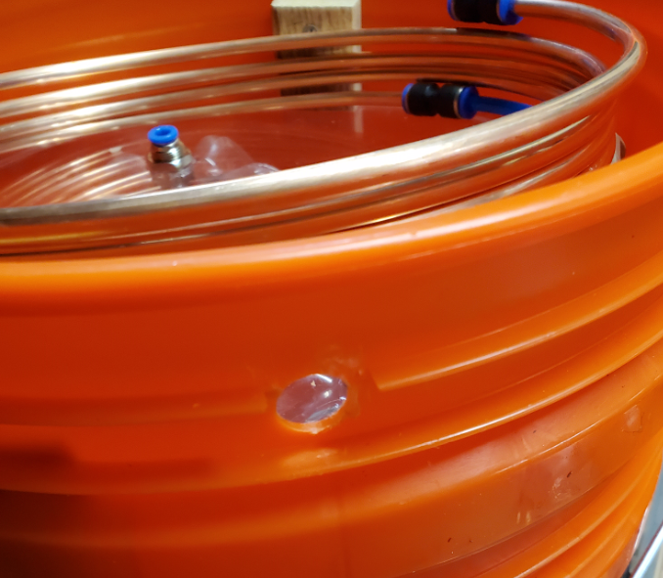

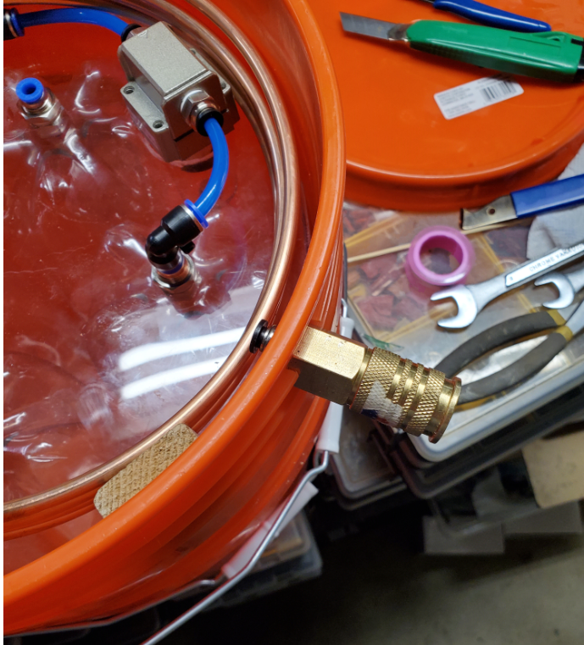

Then, a ¼ line is added to connect the copper tubing to the Quick Connect.

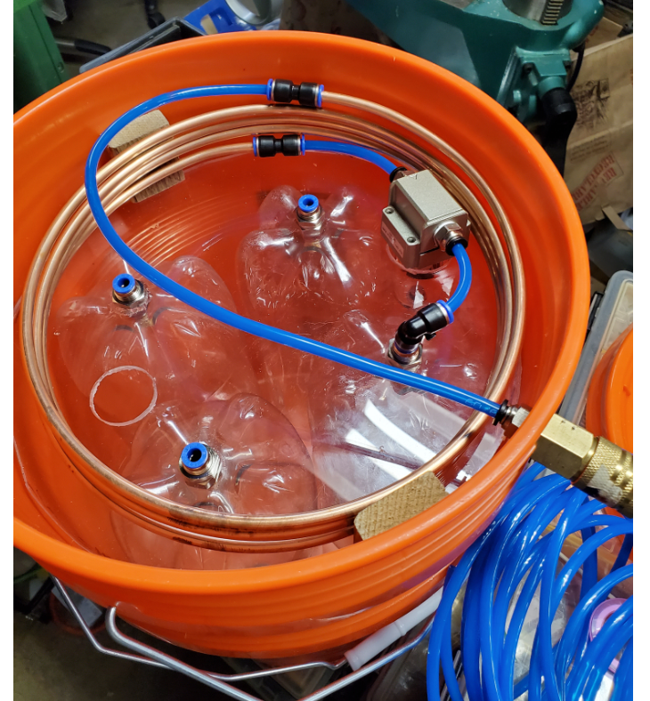

### (optional) Add two pressure gauges to the top of each zeolite tank

While optional, this step is very useful later on for pressure testing.

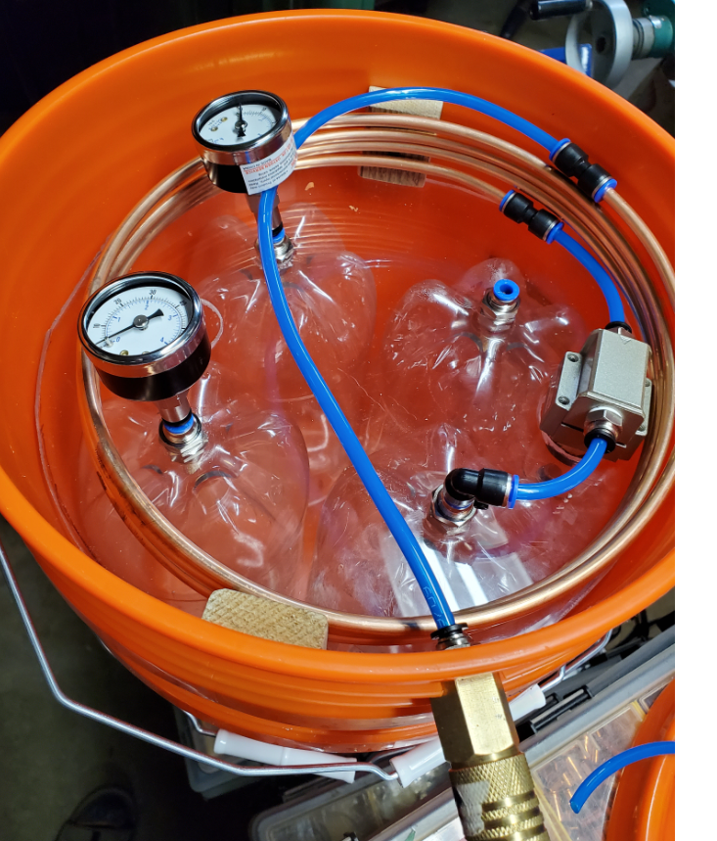

### Add brackets around the copper tubing

This is important as it will hold the tube in place as the whole assembly is flipped over when working at the bottom of the device.

We simply used a sheet of Aluminum bent in the right place. Anything similar could be used as well.

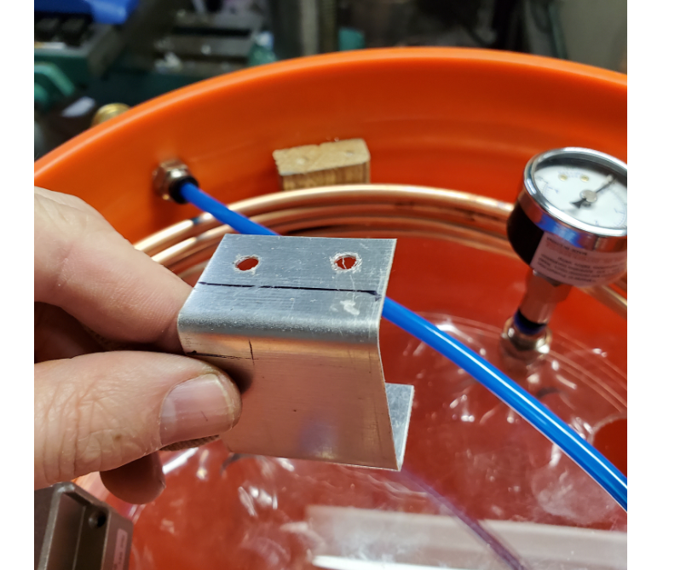

Add screws to hold the brackets in place:

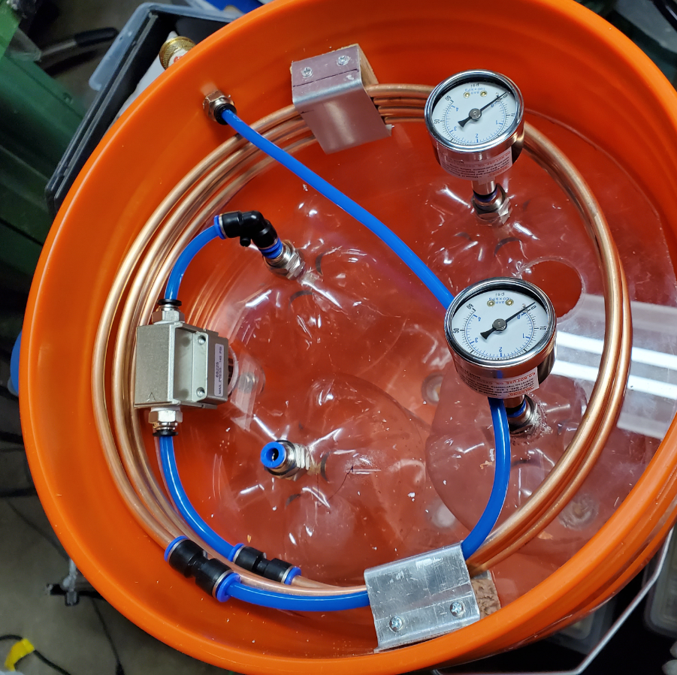

### Construct the lower pneumatic circuit

Flip the assembly over.

Mark the four bottles. Add the 5-way valve and the necessary PTC connectivity.

(yes, I’ve drilled the electrical cable hole **after** I installed the bottles. Silly me. Don’t make this mistake)

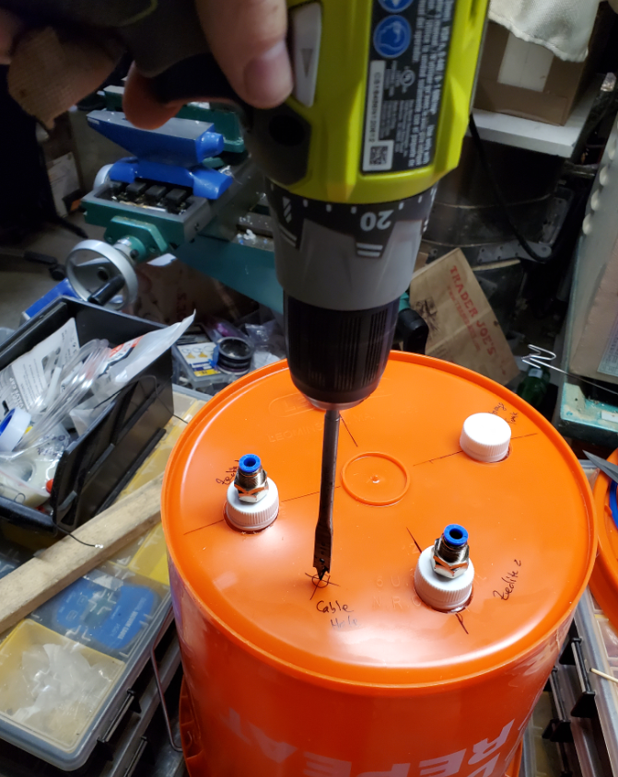

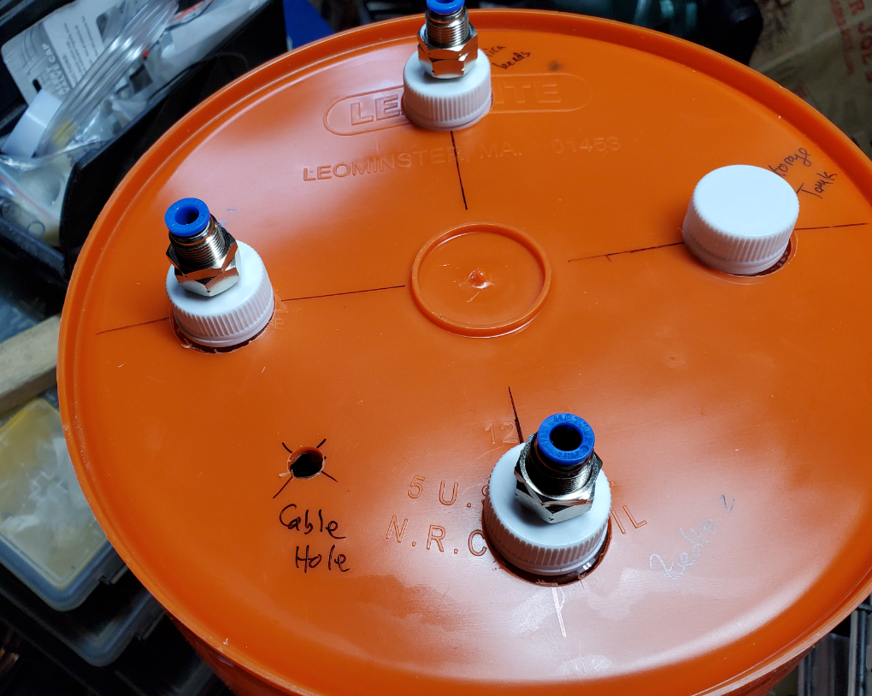

Assemble the 5-way valve.

**Important**: Make sure that the flexible line is not damaged by being pressed by the gap between the two buckets!

Test this by sliding the outer bucket above the whole system.

If things look good, flip back the whole system with the outeer bucket in place.

Do not add zeolite or silica beads yet! We need to complete clear tank pressure testing next.

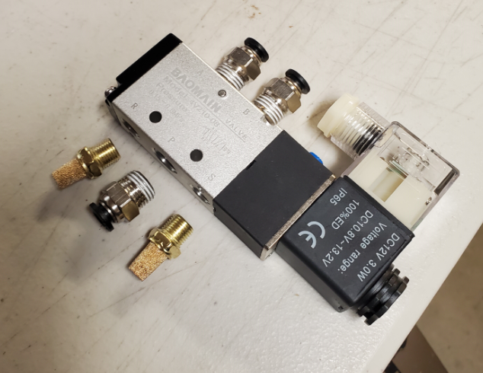

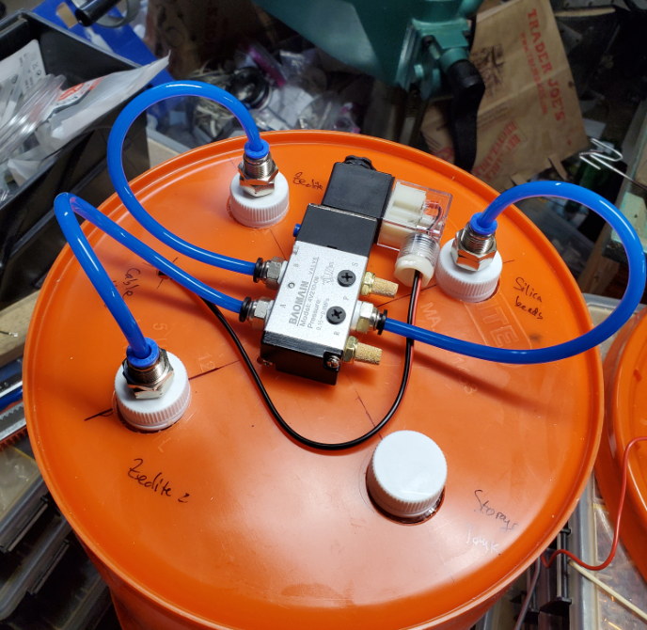

### Assemble the top pneumatic circuit

Given the flexibility of the PTC connectors, there are various ways to do this. The method shown below is just one possible.

If dimensions of a particular pipe segment are wrong, remove it from the PTC connection, cut another piece and repeat the process.

Pay attention to the flow position of the check valves!

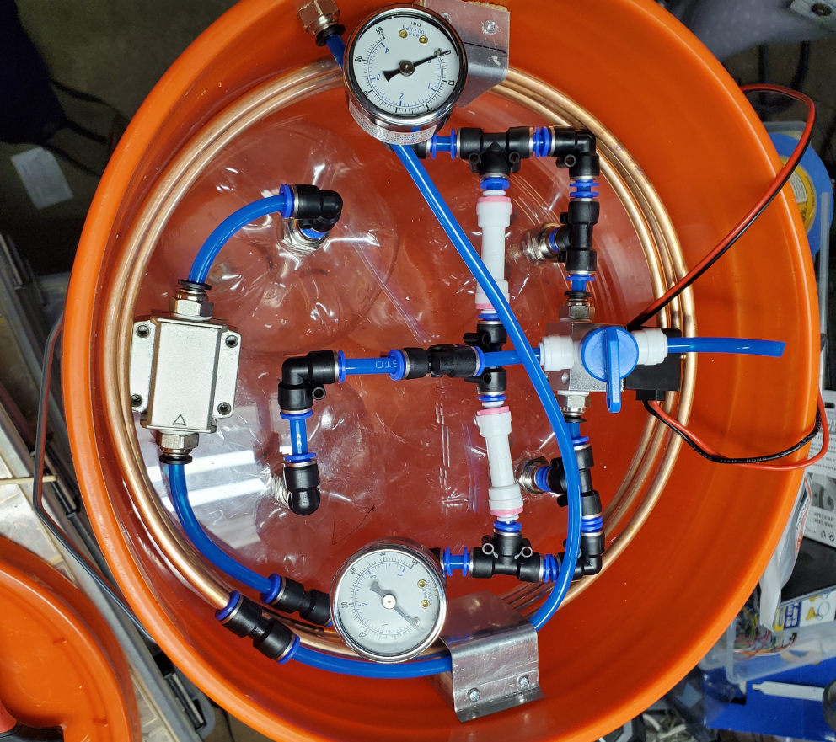

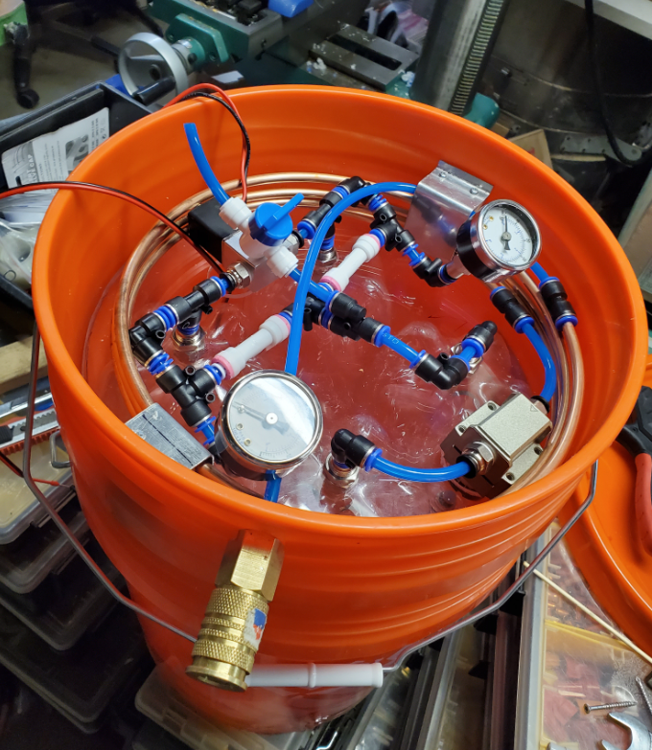

### Clear tank pressure testing

Pressurize the whole system. One of the pressure dials should build up, the other should remain at atmospheric pressure.

Using a 12V 1A source connected to the 5-way valve, you can alternate which tank gets pressurized.

Similarly, using the 12V on the 2-way valve you should connect the two tanks.

A video of the clear tank pressure test process is shown here: <https://www.youtube.com/watch?v=JtceFDTl0cY>

A pressure regulator needs to be added at the entrance of the system to limit the pressure to the value you want. Do not connect directly the assembly directly to the compressor!

This is also a good opportunity to pressure-test the system at a higher value of 60 psi or so (much higher than the typical operational pressure or 25-30 psi)

Stop the compressor. If there are any issues (leaks, hissing, etc.), identify the leak and fix it. The system should be stable and not hiss if things are looking correct. Also, the pressure indicators on the dials should stay constant.

### Load silica and zeolite tanks

Now flip again the assembly over and add zeolite and silica. Make sure you add them in the right tanks!

**Important**: When adding zeolite or silica, it is recommended to use a metallic funnel connected through a wire to the electrical ground. If you use a plastic funnel the zeolite may get electrostatically charged to the extent that zeolite beads may jump out of the funnel and make a mess!

After the zeolite/silica is loaded, flip back again the assembly into its (hopefully) final position.

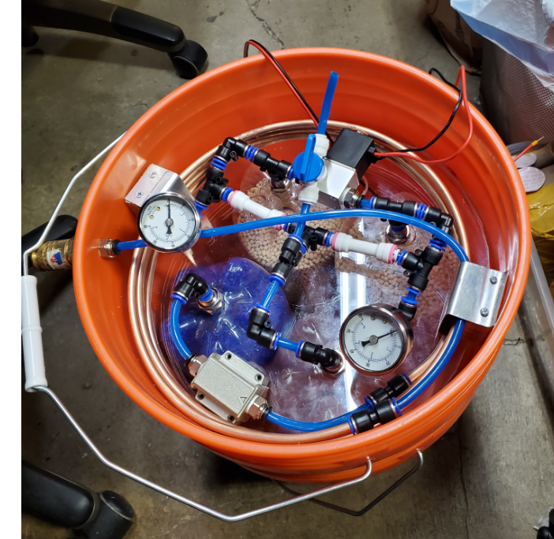

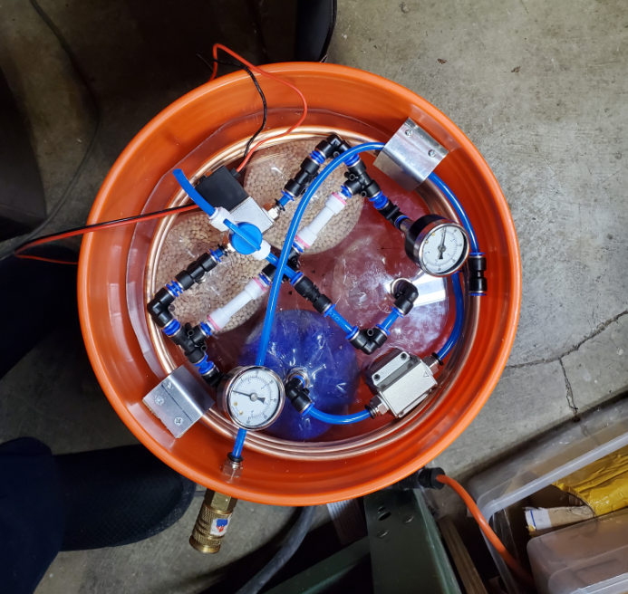

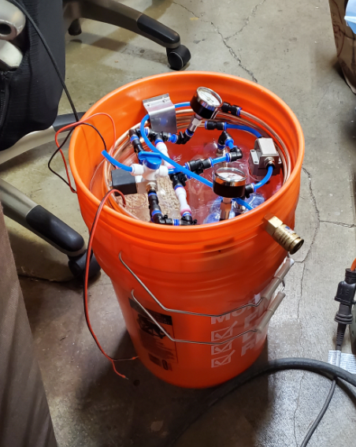

### Pressure test with tanks loaded

Similarly, as before, you can now repeat the pressure test.

You can go up to 50 psi or more. Note: don’t exceed previous tested pressure. Now if the tank burst you will have a mess inside the bucket.

## Building steps – electrical system

### Cut out fan hole in the bucket lid

Measure the diameter of your fan and cut a similar hole in the bucket lid. Also mark down the position of the fan screws

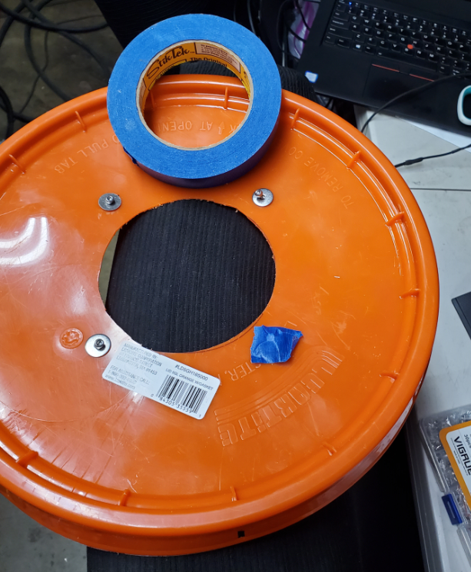

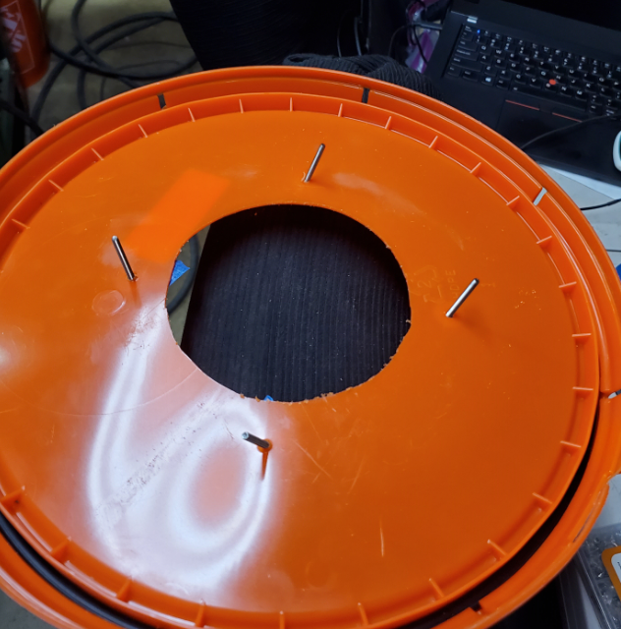

### Add a mesh to protect fan blades from the exterior

Any mesh cut out will work. I simply used a piece of metallic mesh I had in the garage.

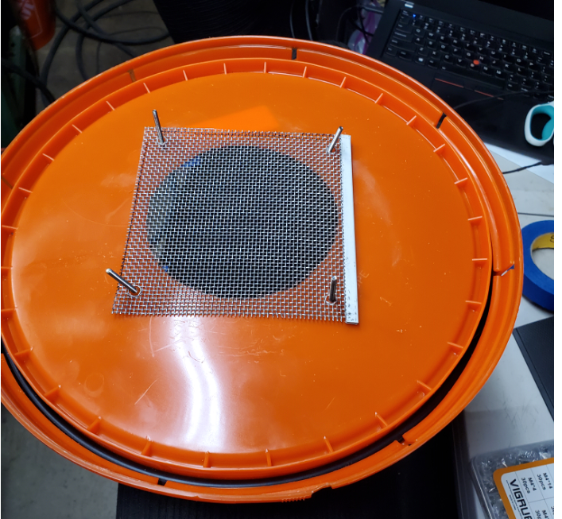

### Assemble the fan

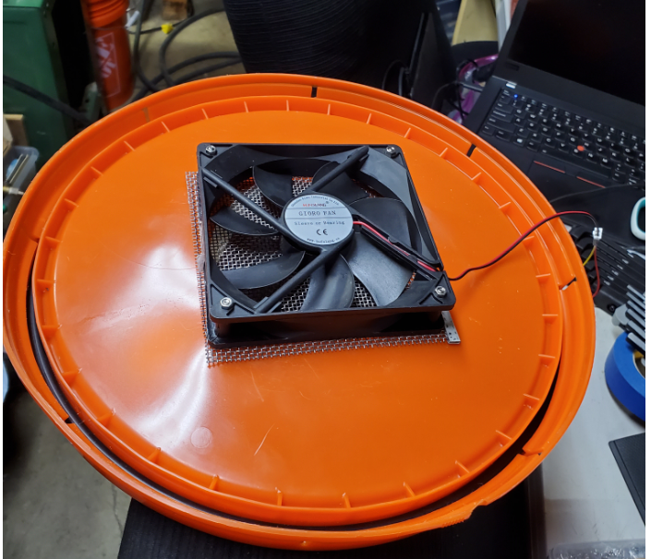

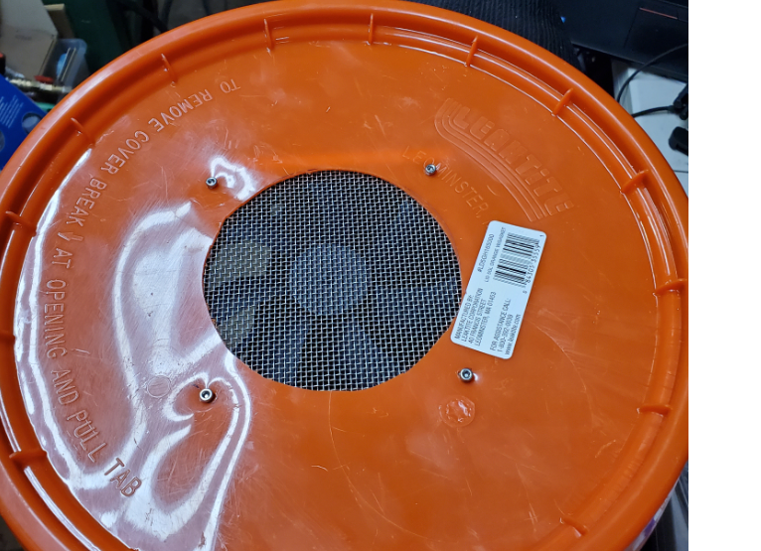

### Connect the Arduino with the ULN2003 board

Pinout connection instructions in the .ino file on GitHub[13].

Please also see this diagram[14]:

This is also a good opportunity to program the Arduino board to ensure it lights up the LEDs on the ULN2003 board correctly.

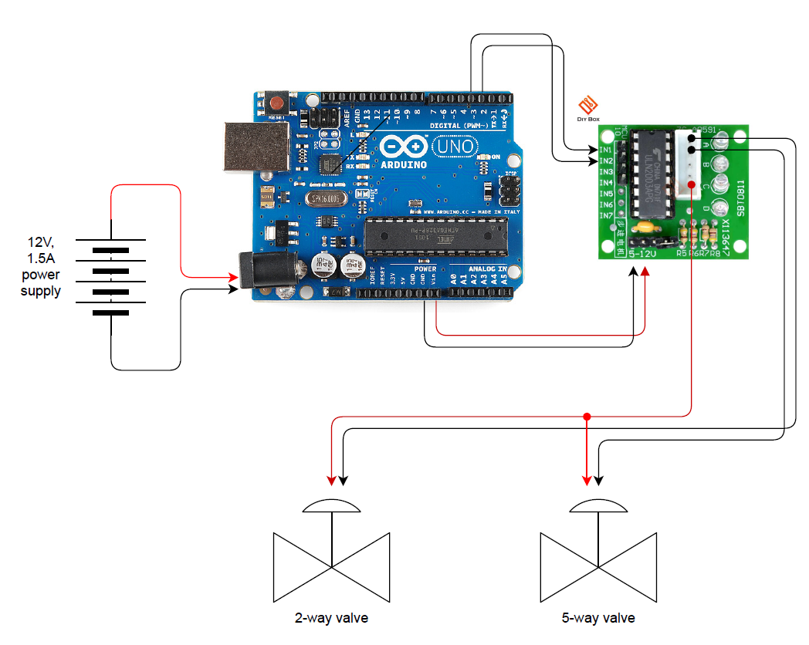

### Mark down the mounting holes for the Arduino board

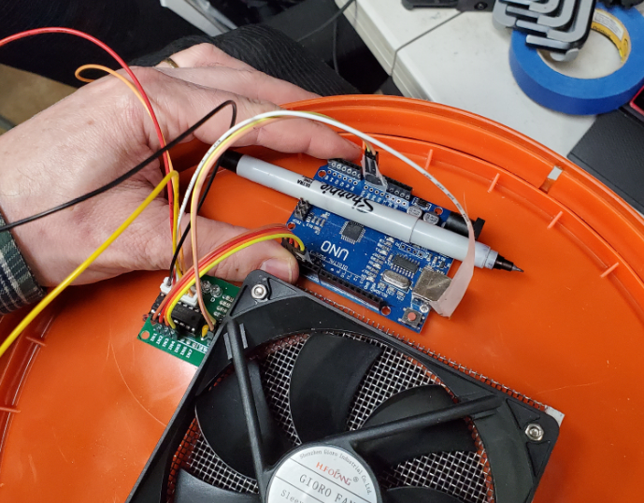

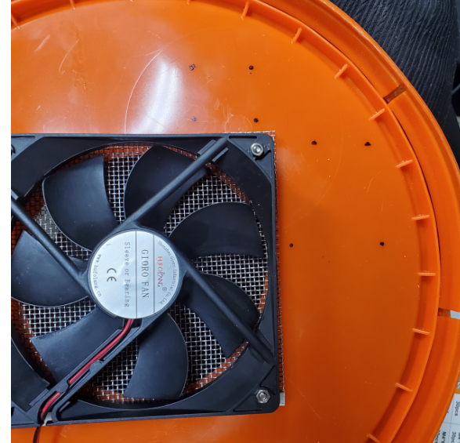

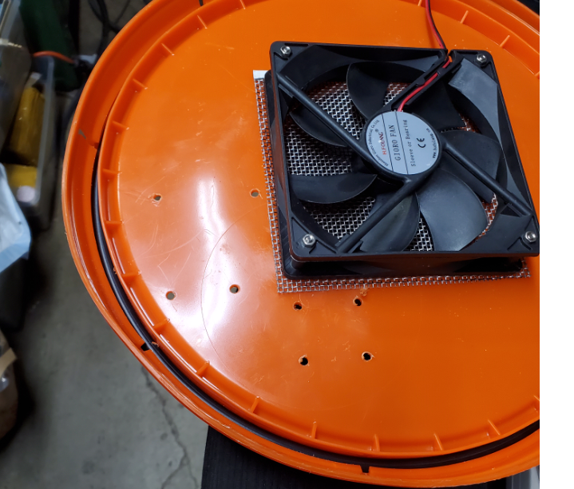

### Mount the Arduino and ULN2003 boards

Make sure you leave room for the power connector, the USB connector, etc.

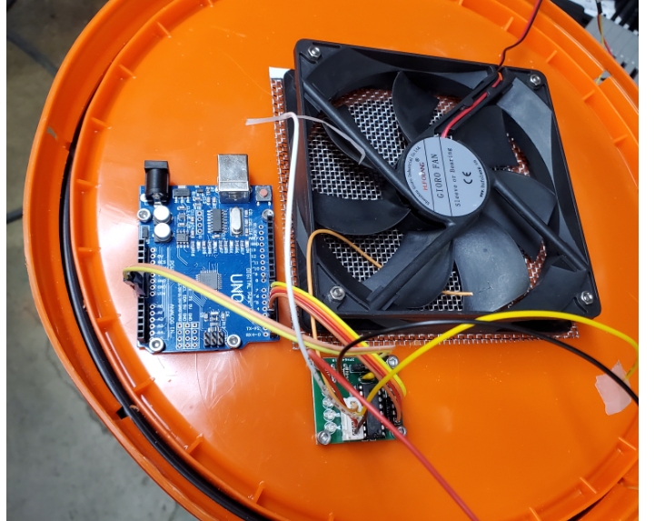

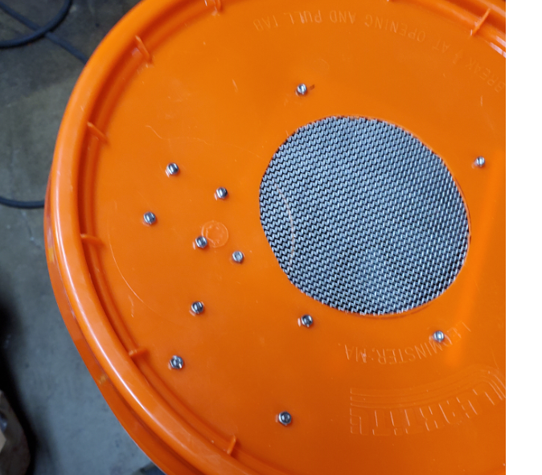

### Install connection block array

Optionally (but highly-recommended) install the connection block arrays. You should also label the connectors to be clear which wire goes where.

It is recommended to use push-style connector array as you may need to detach the lid to periodically program the Arduino.

After you connect the valves you can also power the Arduino.

Ensure that the valves are clicking in the right order.

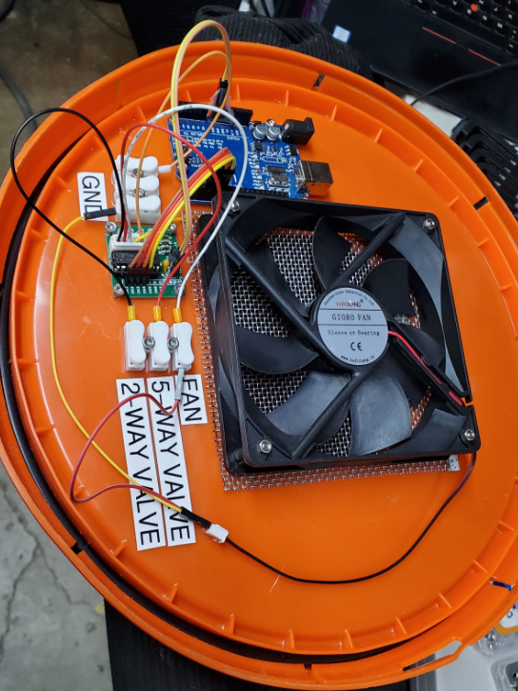

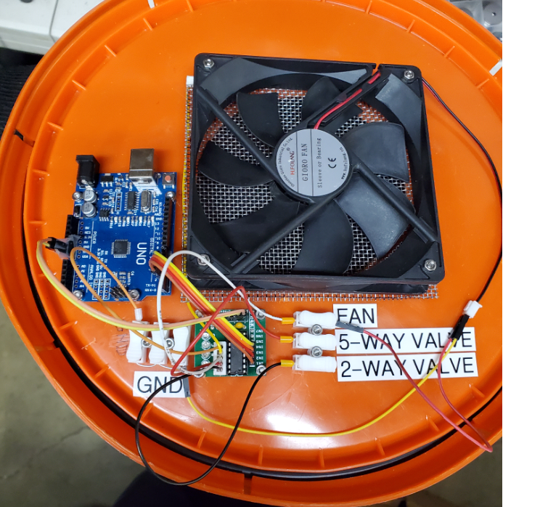

### Pressurize and test the system with the Arduino driver

Sample test video provided here: <https://www.youtube.com/watch?v=6LtmqhrYTvo>

Please ensure that the valves are clicking and releasing air in the right order.

The system should now generate O2-rich atmosphere. This is also a good opportunity to test the O2 sensor.

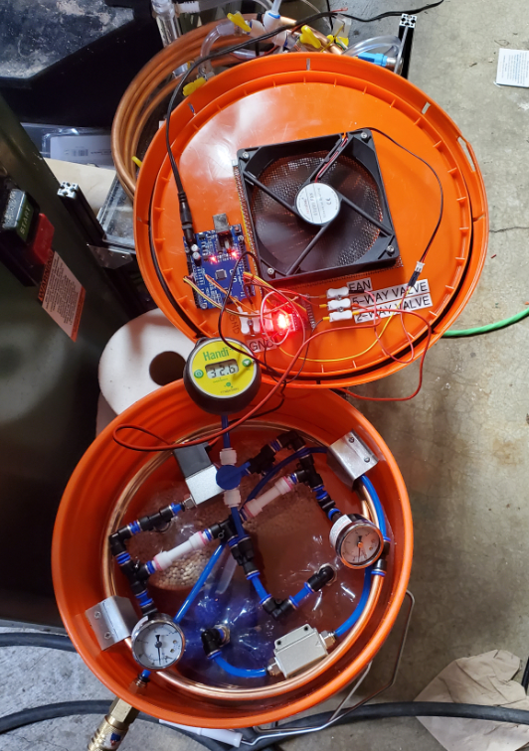

1. <https://en.wikipedia.org/wiki/Pressure_swing_adsorption>
2. Adsorption is not to be confused with absorption which is a different process.
3. <http://kexhu.people.ust.hk/ceng521/521-7.pdf>
4. Simple description of the Skarstrom cycle: <https://ethz.ch/content/dam/ethz/special-interest/mavt/process-engineering/separation-processes-laboratory-dam/documents/education/math%20notes/Gas_separation_-_PSA.pdf>
5. <https://drive.google.com/open?id=1mU656quP_6XyR5HLY6X_9pNClavfAClQ>
6. Need to define tables with exact dimensions in both measurements systems (metric vs. imperial)
7. BOM v2: <https://drive.google.com/open?id=1uhydc6EWnSvJewcNsdP_nE50qGTm_na4fWFWcP1NZB8>
8. This was a lesson we learned from Prototype V1 which used Makerbeam XL 15x15 T-slot which has proven too flimsy as a supporting structure. Use of T-slot materials also possible but we recommend thicker T-slot such as 20x20 or 30x30.
9. You might find such plastic plates as scrap material – check your local stores. Tap Plastics sells 1 ft x 1 ft squares for $2/lb as scrap material.
10. The Skarstrom patent originally used 5A zeolite
11. Sigma-Aldrich has a good source: <https://www.sigmaaldrich.com/chemistry/chemical-synthesis/learning-center/technical-bulletins/al-1430/molecular-sieves.html>
12. The prototype v3 will have a custom PCB that will provide this functionality
13. <https://github.com/oxycon/ProjectApollo/tree/master/Prototype%20oxygen%20concentrator/src/Arduino/Apollo_valve_cycle>
14. <https://github.com/oxycon/ProjectApollo/blob/master/Prototype%20oxygen%20concentrator/Drawings/v1/PDF/Arduino_schematic.drawio.pdf>